Old Guildford Public School Learning at Home Grid – Stage 2 – Week 1
You will not need access to a digital device to complete the following activities. You will need help from a parent/carer.
WEEK 1 | Monday | Tuesday |  | Wednesday |  | Thursday |  | Friday
Before School | Eat breakfast, brush your teeth, dress in school uniform. Have your learning pack ready. Be ready to learn.
Session 1  9am-10.30am  NOTE Comprehension & Spelling booklets are weeks 1-10. | ENGLISH  Reading- Read a book for 15-20 minutes.  Comprehension  Select 10 words from the book you are reading and write the meanings of these words.  Journal Writing – complete a journal entry to answer the question:  How am I feeling this morning? |  | ENGLISH  English Unit – Read a book for 15-20 minutes.  Spelling – Select 10 words you have come across in your book and write them as your spelling list on a piece of paper.  Journal Writing – check the fridge and pantry. Write a shopping list for 15 most common items there, in alphabetical order. |  | ENGLISH  Reading- Read a book for 15-20 minutes.  Comprehension  Draw the main character from the book you’re reading. Show them as a baby, at the same age as in the story and middle aged.  Journal Writing – complete a journal activity to explain:  The best thing about my family is…. |  | ENGLISH  English Unit – Read a book for 15-20 minutes.  Spelling – Use the “Look, Cover, Write & Check” method to learn to spell the words.  Journal Writing – Explain a the rules of a game you like to play at home (eg cards, board game etc). |  | ENGLISH  Reading- Read a book for 15-20 minutes.  Spelling – Ask a family member to give you a spelling test on the words you selected from the book.  Journal Writing – Write your favourite recipe in your journal.
Recess | Eat a healthy snack. Drink some water. Play a game. Get active!
Session 2  10.55-11.55  11:55-12:25 | MATHEMATICS  If the answer is 256, what could the number sentence be?  eg 257-1 = 256  What are the most complication equations you can come up with?  PDHPE-  Create a safe obstacle course in your backyard using what’s already there. You might crawl under outdoor furniture or run along the fence line. Draw a picture of your obstacle course. |  | MATHEMATICS  Have a go at mapping out your school from memory. See how much detail you can include and discuss your map with your family to add more detail?  PDHPE-  Practice your throwing and catching skills by yourself or with someone at home. See if you can catch with one hand or if you can add claps in between catching the ball! |  | MATHEMATICS  Raja has $25.25 in her pocket. She has both notes and coins. What notes and coins might she have to make the sum? List 10 possibilities. Which one weighs the most? least? Why?  PDHPE-  Create a mind map of activities you can do each day to keep your body and mind healthy eg yoga, playing outside, meditating, doing a kind action. |  | MATHEMATICS  Max has some 3D objects. Help him draw a creative picture. Max has 2 spheres, 1 cone, 4 rectangular prisms, 2 triangular prisms and 1 cube. Draw some creative pictures using Max’s shapes.  PDHPE & ART  Pretend you are the head chef in your family home. Design a healthy menu for an entire day at home. Present the menu to your family in a creative way. |  | MATHEMATICS  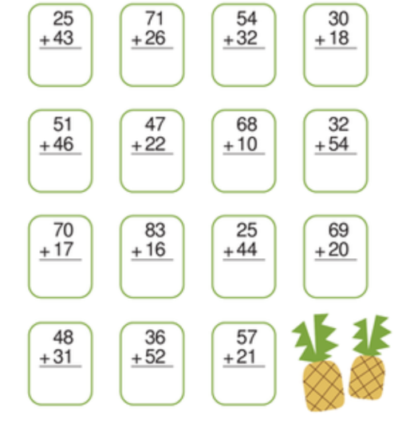  Copy & complete these:  PDHPE  Choose a mindfulness activity (eg finger breathing exercises). Complete these for 1 minute slowly.
Lunch Break | Eat a healthy lunch. Drink some water. Play a game. Get active!
Session 3  Afternoon  12.50-1.50 | PROBLEM SOLVING:  Ali loves planting colourful flowers in his garden. Today, he has 2 yellow, 3 red, 4 orange and one 1 pink flower. He wants to plant them in 1 straight line. Draw some possible flower arrangements. |  | DRAWING:  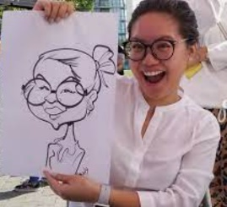  Draw a caricature- a funny, cartoon-like picture of yourself. Make sure to add as much distorted details as you can. Are you still recognisable? |  | SYMMETRY NAME ART  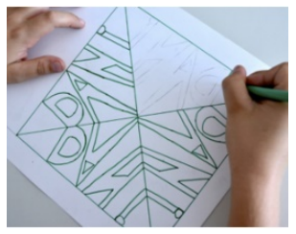  Use a square paper, fold it two times to make four triangles. Then bubble write your name four times in each triangle and colour it in. |  | ART & SCIENCE  Make and decorate a paper aeroplane. Measure how far the plane flies. Repeat the flight three more times and average the measurements. Try a new design to see if you can make a better version. |  | SURVEY & GRAPH  Ask each member of your family what their favourite colour is. Show their answers in a graph.
Fruito Break | Eat a healthy snack. Drink some water. Play a game. Get active!
Session 4  2.15-3.00 | MUSIC:  Make a musical instrument using recycled materials. Be creative! |  | 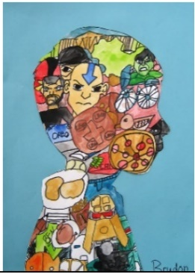  ART:Favourite THINGS  Use your shadow to trace the side of your head and then draw things that you like, and part of your life inside. Colour it in carefully. |  |  |  | ART:  Design a new country flag. |  | DANCE:  Make up a dance sequence and perform it for your family.
IF YOU HAVE A COMPUTER AT HOME< CHECK THESE:
ABC Education https://education.abc.net.au/home#!/games Bitesize https://www.bbc.co.uk/bitesize/levels/zbr9wmn;
Amazing Spelling Fleas https://www.tvokids.com/school-age/games/amazing-spelling-fleas FunBrain https://www.funbrain.com/
Puzzle of the Week http://www.puzzleoftheweek.com/puzzle-library PBS Kids https://pbskids.org/ National Geographic Kids https://www.natgeokids.com/au/

