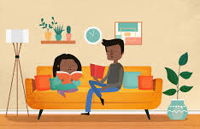
Stage One Learning from Home Grid

- Colour in each grid activity once you have completed it.
- Don’t forget to read for at least 15 minutes every day.

WEEK 1
Monday | Tuesday | Wednesday | Thursday | Friday
English  Re-arrange the letters to make the word for each picture.  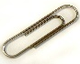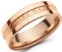  l p i c ng r i  Think of and write other words that end with the following:  ip, ag, ng, ack | English  Read a picture book and retell the story using your own words. Make sure you include the 5Ws in your writing.  - Who?  - When?  - Where?  - What?  - Why? | English  Create spelling flowers using your spelling words.  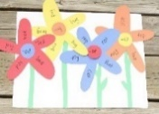  Put the sound of the words in the middle of the flower and write the words around the flower on the petals. You could use coloured paper to make the flowers. | English  Use conjunctions to joint two simple sentences together to make compound sentences.  Use the words, ‘and’, ‘but’, ‘so’, ‘or’ and ‘because’ to write a compound sentence each. | English  Think about your favourite animal. Write some interesting information about it.  - What type of animal is it?  - What does it look like? Use adjectives (describing words) to describe it.  Where does it live?
Maths  Make as many numbers as you can using the following numerals:  3 0 5 1  Read and write them after you have made them, eg. 30 – thirty, 13 – thirteen.  Challenge: Can you make some 5-digit numbers by using one of the numerals twice? | Maths  Before My Number After  13 14 15  Make one set of number cards from 0 to 9. Make a 2-digit number and record the numeral before and after like below:  Challenge: Can you make some 3-digit numbers and work out the number before and after? | Maths  Explain how you can solve the following number facts.  15 + 10 = 26 + 10 =  15 + 20 = 26 + 30 =  15 + 30 = 26 + 50 =  15 + 40 = 26 + 70 =  What is your strategy to solve these questions? Is there another strategy? Which strategy is the most efficient? | Maths  Use different 2D shapes to create a picture or an artwork. Examples are shown below:  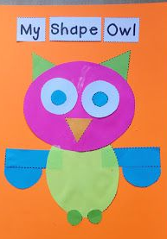 | Maths  Collect 10 different sized objects. Line them up to compare their lengths. Order them from the shortest to the longest.  Challenge: Use a ruler to measure, compare and order the objects from the shortest to the longest.
Free Choice Activity  Cooking  Help your family make a breakfast at home. Set the table and do the dishes. | Free Choice Activity  Build a tower  Build the highest tower you can using lego, books, pillows or other items in your house. | Free Choice Activity  Create a funny video  As a family create a short 15-20 second funny video (eg. dance, singing, playing). | Free Choice Activity  Story Time  Choose a book to read to a family member or ask them to read it to you. | Free Choice Activity  Quiz Night  Each family member writes down 5 to 10 maths or general knowledge questions and quizzes the rest of the family. Who answers the most questions correctly?
WEEK 2
Monday | Tuesday | Wednesday | Thursday | Friday
English  Syllables are beats in words.  Clap the syllables of objects you have around the house & write them in the correct column  Example: com-pu-ter has 3 syllables, draw it in column 3.  How many syllables?  1 2 3 4 | English  Read a book and choose ten spelling words to write down using Look Cover Write Check. | English  Write the name of a fruit for every letter of the alphabet eg. a – apple, b – banana.  To challenge yourself, think of an adjective (describing word) to describe it eg. Crunchy apple, yellow banana. | English  Read a newspaper and write down as many words as you can with the digraphs (ch, sh, th).  Choose 3 or more words with the same digraph sound and make fun alliteration sentences eg. Charlie chased the chickens into the chimney. | English  What can you see out your window or door? Use this sentence starter to begin: Today I looked out of my bedroom window and I could see…  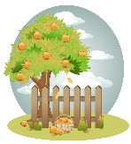  eg. Today I looked out of my bedroom window and I could see a wooden fence and tall trees. Draw a picture of what you can see.
Maths  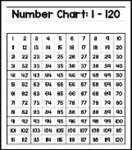  Use a number chart to count by 2s, 5s and 10s. Write those numbers down. What patterns do you notice in your number chart? | Maths  Roll a die twice to record a 2-digit number. Roll the die again to record a 1-digit number. Find the difference of the two numbers eg. 26 – 4 = ?. Use different strategies to work out the difference. | Maths  There are 5 more dogs than there are cats in the pet shop. How many of each pet might there be? How many pets might there be in total?  Record your answers in your book. | Maths  Look around your room/house and find repeating patterns. Draw the patterns you find.  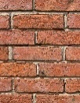  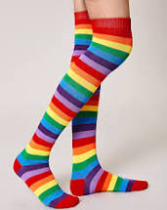 | Maths  Read and record different times throughout the day. What time did you…  - wake up in the morning  - eat your breakfast  - do your homework  - read a book  - go to bed
Free Choice Activity  Speed Cleaning  Help your family clean the house and time yourself. Write that time down and see if you can beat it the next day. | Free Choice Activity  Picnic time  Set up a picnic for yourself and some of your toys. Eat your recess or lunch. | Free Choice Activity  Indoor obstacle course  Use items like pillows and make a course you complete. Time each family member to see who gets the best time. | Free Choice Activity  Thank you letter  Write a thank you letter to someone in your family or to your teacher. | Free Choice Activity  Treasure Hunt  Play a treasure hunt with someone in your family. Hide ‘treasure’ items around the house eg toys/books and challenge them to find the items.

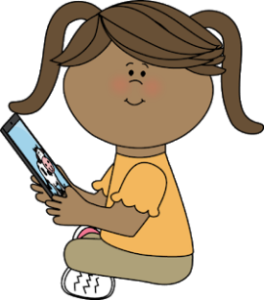
Educational Websites to Support Learning

English | Maths | Fitness | Other
https://stories.audible.com/discovery/enterprise-discovery-21122356011?ref=adbl_ent_anon_ds_ds_dccs_sbtp-0-1  www.storyboxlibrary.com.au  www.getepic.com  https://kids.scholastic.com/kids/books/dav-pilkey-at-home/  https://www.abcya.com  https://www.teachyourmonstertoread.com/  https://www.mystorybook.com/​ | https://www.topmarks.co.uk/maths-games/5-7-years/counting  https://www.arcademics.com/games?grade=1  http://www.sheppardsoftware.com | https://family.gonoodle.com/  www.cosmickidscom  https://qalo.com/blogs/qalo-life/12-at-home-workouts-to-do-with-your-kids  https://kidsactivitiesblog.com/25870/physical-fitness/  https://www.activekids.com/fitness/articles/full-body-conditioning-exercises-for-kids  https://www.verywellfamily.com/easy-exercises-for-kids-1257391  https://insighttimer.com/meditation-topics/kids-meditation | https://taronga.org.au/taronga-tv#latestkeeperchats  https://iview.abc.net.au/show/mister-maker  https://www.abcya.com/games/abcya_paint  http://www.nickjr.com.au/create/  https://www.learninggamesforkids.com/art-and-music-games.html  https://www.colorwithleo.com/art_portraitfun.php​

