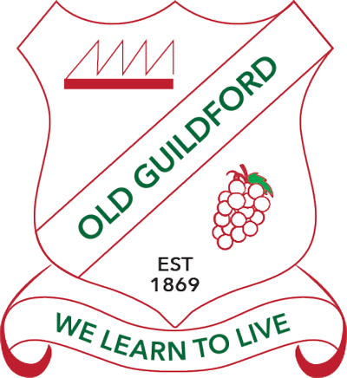
Preschool Learning at Home

Do the activities you like lots of times and send some photos to the school Facebook page!
- Read every day to a member of your family. You can also watch Storyline On line on You tube
https://www.storylineonline.net/
- Keep active, take breaks, eat healthy food and drink water. This will help you learn
Numeracy: Water play  Filling and pouring water into different sized bottles and containers helps your child learn about volume and capacity.  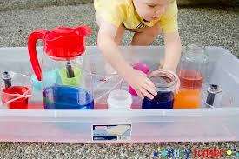 | Life Skills:  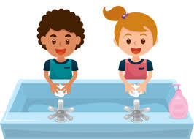  Wash your hands! Can you count backwards from 10?  10 9 8 7 6 5 4 3 2 1 0 | Fine motor:  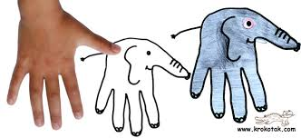  Trace around your hand and draw an elephant! | Art and craft:  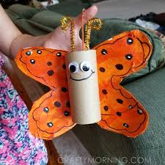  Use a toilet roll and paper to make a butterfly. Draw on eyes cut think paper strips for the feelers. | Gross motor:  Can you walk around the house balancing a book or soft toy on your head?  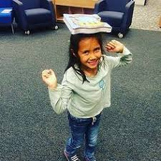
Life skills:  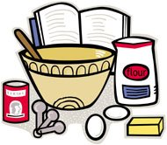  Help mum or dad cook something. | Life skills:  Make your own lunch, with a grown-ups help. Maybe try a funny face sandwich!  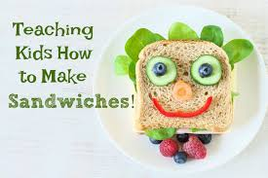 | Gross Motor:  Play outside!  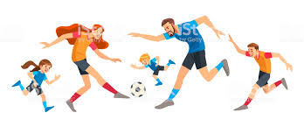  Run, jump, hop and gallop. Throw or kick a ball to someone. | Fine motor:  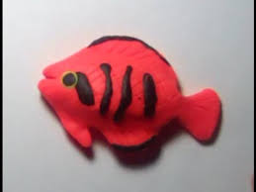  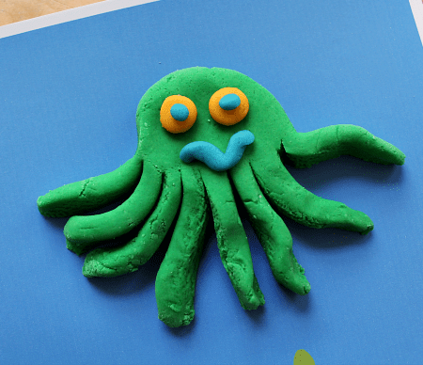  Use playdough to make some sea creatures. | Gross Motor:  Play a game of musical statues. Dance and move to your favourite music and when it stops you freeze!
Life Skills:  Practice putting on your shoes and learning how to tie laces.  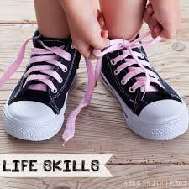 | Fine motor:  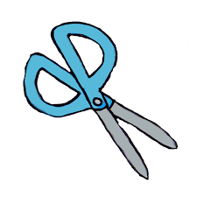  Draw something and then cut it out. | Literacy:  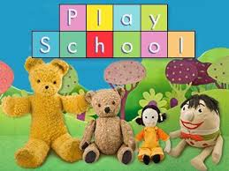  Watch playschool and ABC kids. Sing along with the songs and maybe try making the craft. | Numeracy:  Count how long it takes you to do some jobs, like getting dressed or making your bed.  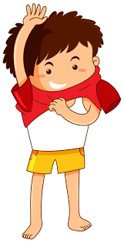  1 2 3 4 5 6 7 8 9 | Literacy:  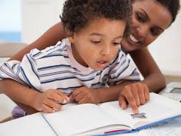  Read a book with someone. Practice holding the book, turning the pages and talking about the pictures.

