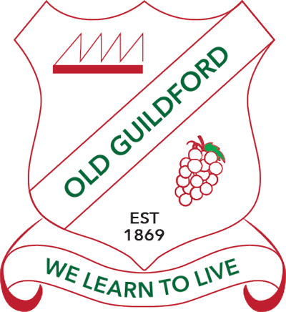
Preschool Learning at Home

Complete the following learning activities in any order you like. Do the ones you like lots of times!
- Read every day to a member of your family. You can also watch Storyline On line on You tube
https://www.storylineonline.net/
- Keep active, take breaks, eat healthy food and drink water. This will help you learn
Literacy:  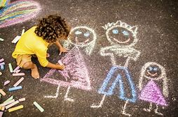  Use chalk to draw on the footpath or driveway. Can you draw your family? | Numeracy:  Line up your teddy’s and toys from tallest to shortest.  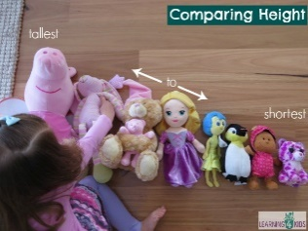 | Fine Motor: Using our small muscles  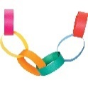  Cut some paper strips, and using your glue, link them together to make a paper chain. | Life Skills:  Help set the table for dinner. How many forks/spoons/knives will you need?  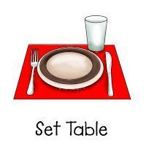 | Name Recognition:  Write your name like a rainbow using lots of different colours.  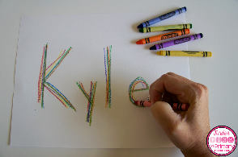
Numeracy:  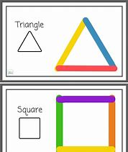  Make shapes using clothes pegs or pop sticks:  Can you make these shapes? | Life Skills:  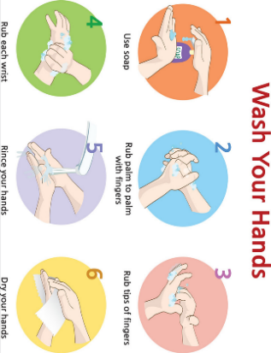  count to 20 as you wash your hands! | Gross Motor: using our big muscles  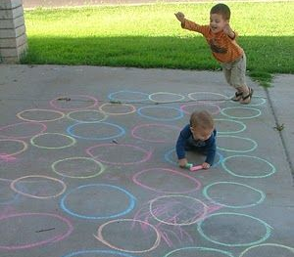  Use chalk to draw circles on the footpath or driveway. Can you jump and hop on the circles? | Literacy:  Make place cards for the dinner table. Cut some paper squares, fold in half, write names and draw a picture for everyone in your family.  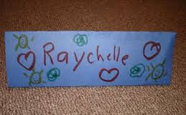 | Literacy:  Sing your favourite preschool songs in the bath or shower!  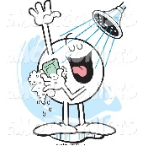  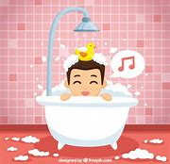
Numeracy:  Order number cards from 1- 10. Now can you do it backwards?  10 9 8 7 6 5 4 3 2 1 | Life Skills:  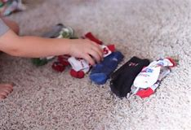  Help Mum or Dad to fold the washing. Can you match the socks? | Fine motor:  Use playdough to make some funny monsters. | Literacy and fine motor:  Trace around your hand on a piece of paper. Turn it into a fish! | Gross Motor:  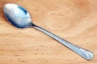  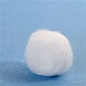  Have a spoon race. Place a cotton ball on a spoon and walk around the house balancing it on the spoon. Don’t let it drop!

