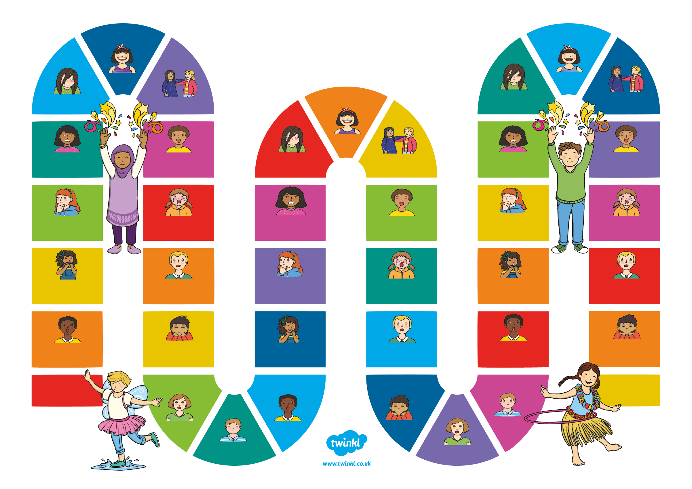

worried

worried

worried

worried

happy

happy

sleepy

sleepy

sleepy

disgusted

disgusted

disgusted

sad

sad

sad

proud

proud

proud

calm

calm

calm

embarrassed

embarrassed

embarrassed

angry

angry

angry

confused

confused

confused

scared

scared

scared

surprised

surprised

surprised

Start

Finish

happy

happy

happy

**Emotions**