[](https://www.google.com.au/url?sa=i&url=http%3A%2F%2Fclipart-library.com%2Fclip-art%2Fschool-clipart-transparent-background-14.htm&psig=AOvVaw19tDlpKvNv-FbOAPhpRqTI&ust=1585572562471000&source=images&cd=vfe&ved=0CAIQjRxqFwoTCMjAk6Dcv-gCFQAAAAAdAAAAABAL)[](https://www.google.com.au/url?sa=i&url=http%3A%2F%2Fclipart-library.com%2Fsmiling-girl-cliparts.html&psig=AOvVaw1q5w-2AslX-u-LAecv-cGa&ust=1585571830487000&source=images&cd=vfe&ved=0CAIQjRxqFwoTCNii6cLZv-gCFQAAAAAdAAAAABAD)[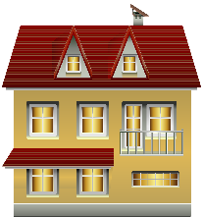](https://www.google.com.au/url?sa=i&url=https%3A%2F%2Fclipartart.com%2Fcategories%2Fclipart-house-png.html&psig=AOvVaw36ZZSbzlNDu2DkyBX_anVY&ust=1585571966182000&source=images&cd=vfe&ved=0CAIQjRxqFwoTCPiQ4ILav-gCFQAAAAAdAAAAABAZ)[](https://www.google.com.au/url?sa=i&url=https%3A%2F%2Fwww.clipart.email%2Fclipart%2Fokay-face-clipart-19675.html&psig=AOvVaw1VqlKkWtecHDGdUlZfGFKN&ust=1585573059274000&source=images&cd=vfe&ved=0CAIQjRxqFwoTCJihmo_ev-gCFQAAAAAdAAAAABAD)[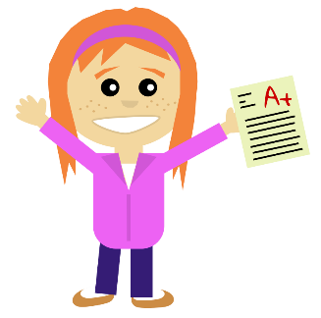](https://www.google.com.au/url?sa=i&url=https%3A%2F%2Fwww.clipart.email%2Fclipart%2Fa%2B-clipart-transparent-background-76601.html&psig=AOvVaw0njGg1ZgFKuO0QqQIKeNxK&ust=1585572239809000&source=images&cd=vfe&ved=0CAIQjRxqFwoTCIjs47zdv-gCFQAAAAAdAAAAABAK)[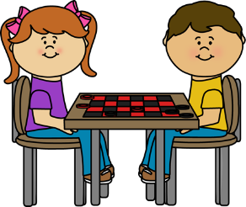](https://www.google.com.au/url?sa=i&url=https%3A%2F%2Fwww.kissclipart.com%2Fcheckers-clipart-draughts-board-game-clip-art-2wzeo5%2F&psig=AOvVaw2aW0BGHIJSb5yzSP83eLXU&ust=1585572075613000&source=images&cd=vfe&ved=0CAIQjRxqFwoTCOC3irfav-gCFQAAAAAdAAAAABAk)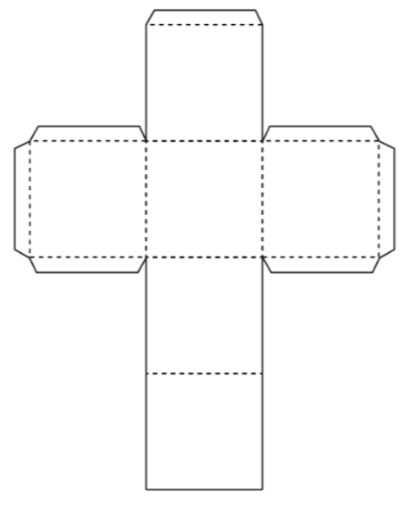

The best thing about my school is…

I’m happy when…

I am good at…

I’m getting better at…

My favourite game is…

The best thing about my house is…